**DAILY ONLINE ACTIVITIES SUMMARY**

|  |  |  |  |  |  |  |  |  |
| --- | --- | --- | --- | --- | --- | --- | --- | --- |
| **Date:** | 19/06/2020 | | | | | **Name:** | CHETHAN CK | |
| **Sem & Sec** | 4th SEM ‘A’ SEC | | | | | **USN:** | 4AL18CS017 | |
| **Online Test Summary** | | | | | | | | |
| **Subject** | | Microcontroller and Embedded Systems(18CS44) | | | | | | |
| **Max. Marks** | | 20 | | **Score** | | | 20 | |
| **Certification Course Summary** | | | | | | | | |
| **Course** | Facial recognition using python | | | | | | | |
| **Certificate Provider** | | | Udemy | | **Duration** | | | 3 Hours |
| **Coding Challenges** | | | | | | | | |
| **Problem Statement:** 1. Write a C Program to Count total set bits in all numbers from 1 to n. | | | | | | | | |
| **Status:** Completed | | | | | | | | |
| **Uploaded the report in Github** | | | | | YES | | | |
| **If yes Repository name** | | | | | https://github.com/alvas-education-foundation/chethan_c_k | | | |
| **Uploaded the report in slack** | | | | | YES | | | |

**Online Test Details:**

The online test was from module 4 which was about the Embedded System Design Concepts. There were 20 questions and the duration was 30 minutes. The questions were optimal and were easy. The score that I got in the test is 20/20.

**Snapshot:**

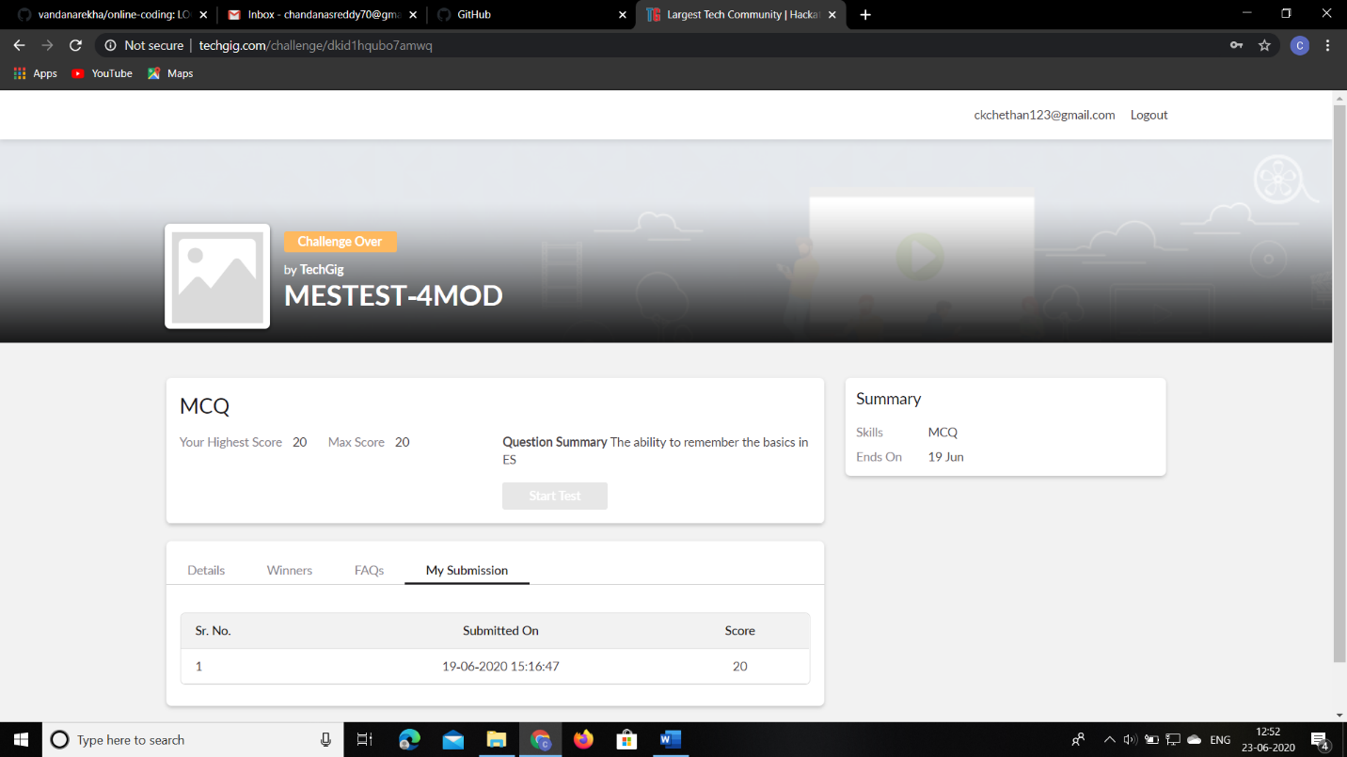

**Certification Course Details:**

**Name of the course**: Facial recognition using python

**Certificate Provider**: Udemy

Today I had learned about multi face landmarks.

**Snapshot:**

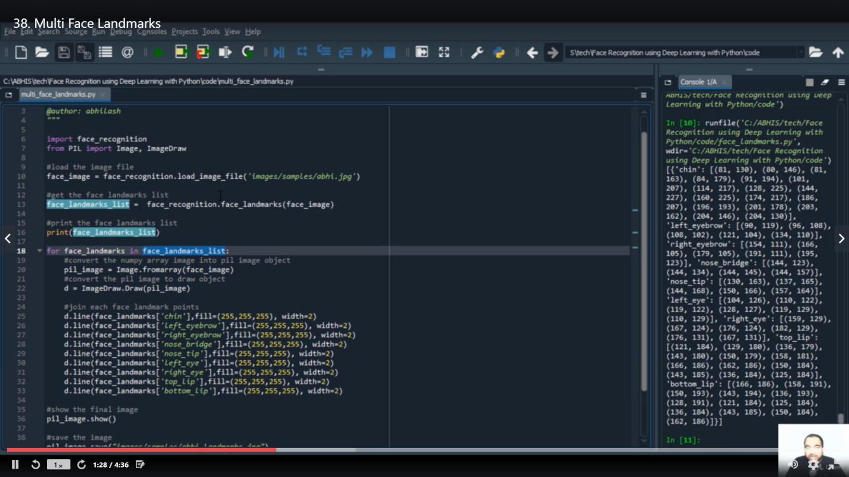

**Online Coding Details:**

Problem 1: Write a C Program to Count total set bits in all numbers from 1 to n.

**Snapshot:**

